K8S helm, elastic and kibana report

In this task application go-demo-app was deployed to K8S using helm. Tested it with the image from google.

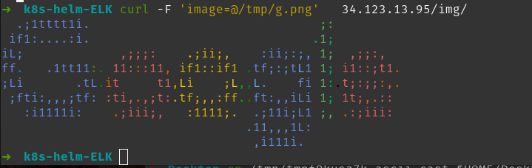

After that the elasticsearch was deployed with the help of operator along with Kibana. Then I deployed fluentBit and connected it to the elasticsearch.

The working logging system was tested using port-forwarding on the localhost.

The code sources and asciinema can be found in the repository k8s-helm-ELK: https://github.com/andrikstravinsky/GLBaseCamp2021

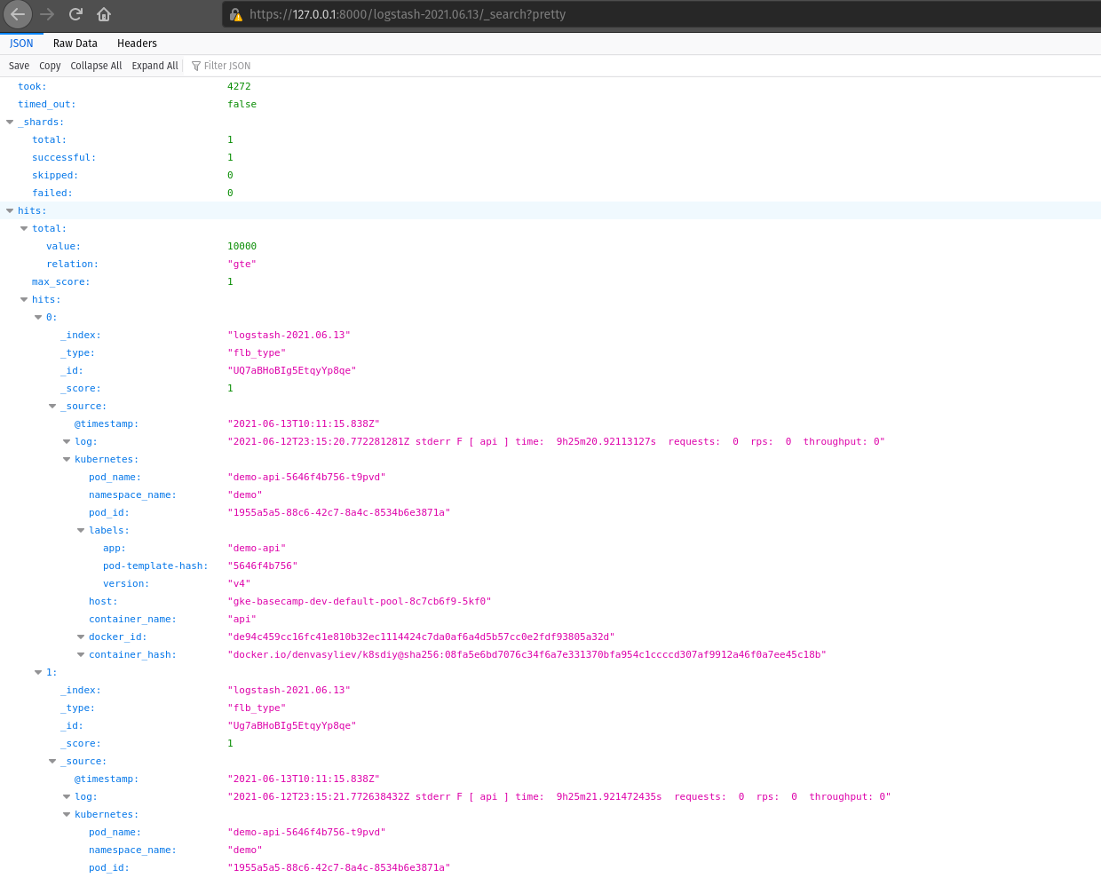

The elastic logstash index

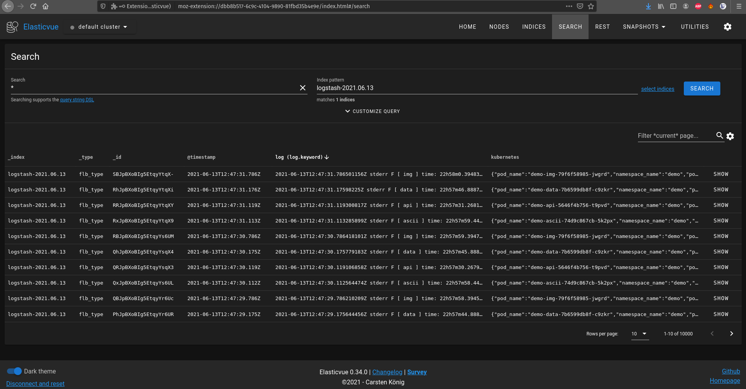

The elastic logstash index via browser extension to work with elastic

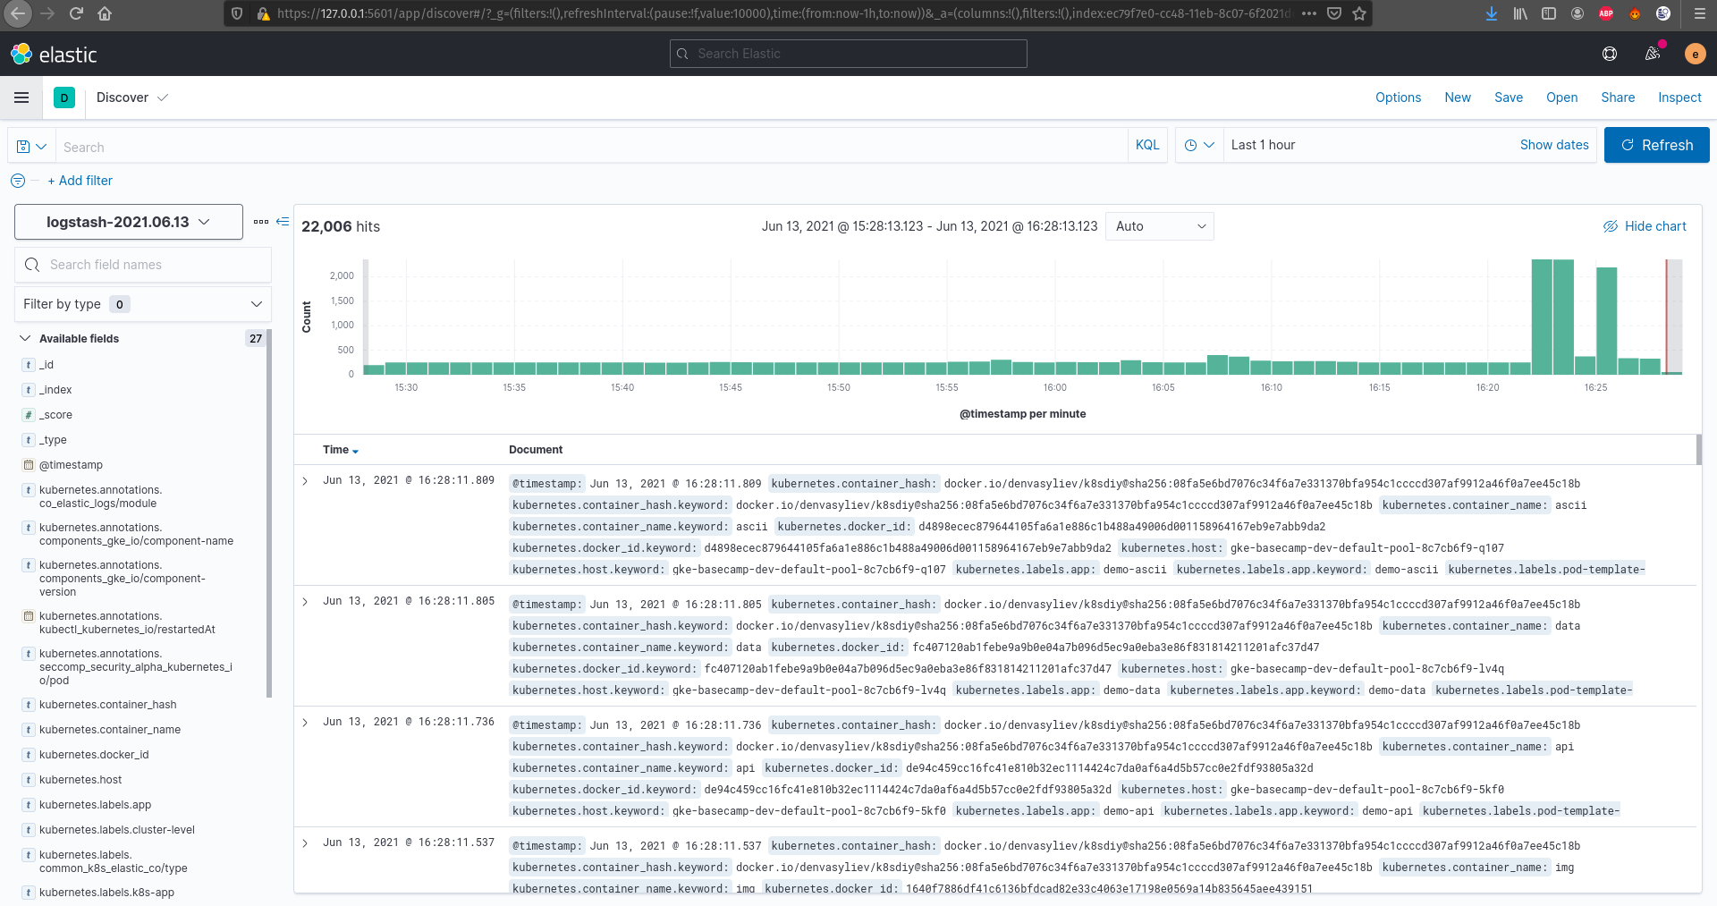

Logs in the Kibana